The Town Where Everyone Talks About Death
March 5, 2014
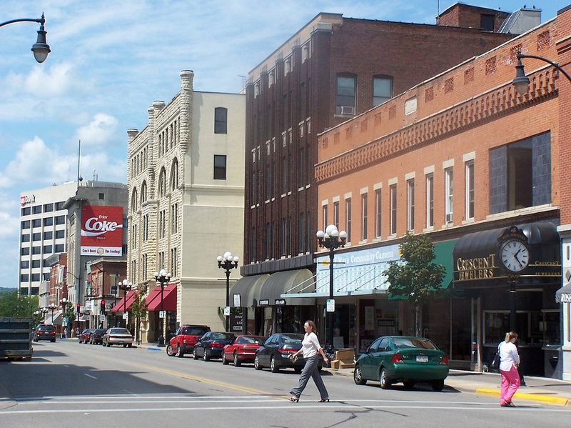
DAVID GREENE, HOST: La Crosse, Wisconsin is like many other cities its size. With just more than 50,000 residents, it has an historic downtown, an annual Oktoberfest, and a Farmer's Market on main street. But there's one thing that makes La Crosse stand out. Nearly everyone there has planned for their death. Ninety-six percent of the people in La Crosse who have died had an advanced directive or some sort of documentation outlining how they wanted to die. Nationally, only about 30 percent of adults have documents like that.
Chana Joffe-Walt, from our Planet Money team, explains how La Crosse got to be this way.
CHANA JOFFE-WALT: I chose a random block in La Crosse to begin, South 30th Street; door to door, just started asking, do you have an advanced directive, a living will?
GEORGE PHILIPS: Oh, yes. Mm-hmm, yup.
JOFFE-WALT: George Philips has his death planned out, as does his wife, Betty.
BETTY PHILIPS: Long time ago, yeah.
JOFFE-WALT: The couple across the street do; the Le Grandes in the red house next door, them too. In fact, in La Crosse, you're unusual if you don't have one. Several people on South 30th Street told me about the Ericksons. The Le Grandes pointed to a white house in the middle of the block and said for some reason, the Ericksons haven't completed their advanced directives.
JOFFE-WALT: So of course, I have to go to the white house and awkwardly mention they seem to have a rap on the block for neglecting to make end-of-life plans - which Randy and Catherine Erickson found amusing.
RANDY ERICKSON: Well, we're having dinner with the Le Grandes tomorrow, and maybe we should bring over our forms.
(LAUGHTER)
CATHERINE ERICKSON: They will definitely ask us again about it, I'm sure.
JOFFE-WALT: The Ericksons' teenage daughter, Annie, jumped in: I know what to do.
ANNIE ERICKSON: I know for sure if my mom is ever stuck in a coma and there's no hope for her, that she wants me to pull the plug; and probably my dad, too.
JOFFE-WALT: Is she right?
RANDY ERICKSON: Yes.
JOFFE-WALT: This is not a comfortable conversation for me because I am from the America where talking about death is like talking about sex. You don't do it - at least not a lot, and definitely not on a random Wednesday evening with your parents. But Annie happens to be from this one, tiny pocket in the country that just does death differently. She tells me she's got a song picked out for her dad's funeral.
ANNIE ERICKSON: It's Bruce Springsteen's "Terry's Song."
JOFFE-WALT: Why have you already picked one out for your dad?
ANNIE ERICKSON: I don't know.
RANDY ERICKSON: It's a good funeral song. You know, it's a, I mean the funny thing is, it's like a hidden track on one of his CDs.
JOFFE-WALT: I feel like you're totally missing the point of his question.
(LAUGHTER)
JOFFE-WALT: JOFFE-WALT: But why have you, at 17, imagined the song that you'll sing at your dad's funeral?
ANNIE ERICKSON: I'm not actually sure how it's become such a comfortable conversation. (Laughter)
JOFFE-WALT: Here's how death has become such a comfortable conversation in La Crosse. It's basically all because of one guy in town, Bud Hammes. Bud works at one of the local hospitals, Gunderson Health Systems, as a medical ethicist. For years, Bud would get called in when someone's dad had a stroke, was in a coma, on machines; and Bud would sit down with the family to try to help them figure out what to do next. Every time, he says, the discussion was excruciating.
BUD HAMMES: What do you think Mom would want? I don't know. Did Dad every say anything to you? The moral distress that these families were suffering was palpable. You could feel it in the room.
JOFFE-WALT: Bud says the thing that was maddening about these conversations was most of the time, they'd be talking about a patient who had been sick for years. Why not have that conversation earlier? So Bud started training nurses to ask people ahead of time, would you like to fill out an advanced directive? It took awhile in La Crosse, but the idea caught on until it got to the point where it is today; where difficult conversations the rest of us spend most, if not all, of our lives avoiding, they happen all the time in La Crosse.
GLEN MULLENCAMP: Make yourself at home.
JOFFE-WALT: OK.
GLEN MULLENCAMP: Beautiful morning, isn't it?
JOFFE-WALT: Glen Muelenkamp is a cheery, 81-year-old farmer sitting in his favorite recliner at home. His prostate cancer has spread to his bones, and he's in hospice. A nurse from the hospital, Laura Weedman, is here to help Glen fill out his advanced directive. Glen's wife, Jenny, is flitting about the room, showing the nurse pictures of every one of her 27 grandkids, And Laura, the nurse, masterfully guides Jenny to a chair next to Glen, to have a conversation Jenny clearly does not want to have.
LAURA WEEDMAN: You know, when people have a chronic illness like you have, sometimes complications can occur.
JOFFE-WALT: Jenny, Glen's wife, is rocking back and forth on the edge of her chair. Her head's turned away from Glen and Laura. Her eyes are locked on a window. Laura, the nurse, starts ticking through some options. OK, Glen, she says. If your cancer spreads, and you reach a point where the treatments will extend your life by a few months, and the side effects are pretty serious...
WEEDMAN: Would you want them to continue to do all of that, or would you say, no; stop?
GLEN MULLENCAMP: Stop.
WEEDMAN: OK.
WEEDMAN: If you had a serious complication from your cancer but you'd probably live through the complication - you would probably not walk again, or you might not be able to talk again - what would you choose them to do: continue to do everything they possibly can for you or would you say, no, stop it?
GLEN MULLENCAMP: I'd say no; stop.
JOFFE-WALT: Glen's wife, Jenny, is still looking at the window at this point, but she started silently weeping. Laura, the nurse, puts a hand on Jenny's knee and forges ahead. OK, Glen, she says. Same scenario. You'd survive, but you'd never know who you are.
WEEDMAN: Would you want them to continue to do everything for you, or would you want them to stop?
GLEN MULLENCAMP: Stop, 'cause I've seen that, where they're just there.
WEEDMAN: They're just there.
GLEN MULLENCAMP: Yeah.
WEEDMAN: And that's not for you.
GLEN MULLENCAMP: No.
JOFFE-WALT: Jenny, the wife, actually gets up at this point, and walks into the other room.
Have you had enough of this conversation?
JENNY MULLENCAMP: (Laughter) I just had to get up and see what was going on.
JOFFE-WALT: Jenny looks around, kind of aimlessly surveying the house. In the living room, the nurse and Glen finish up the plan for the rest of Glen's life - no machines, no feeding tubes, no ventilator or CPR. Stop, stop, stop, stop. Difficult conversations like this one help explain another salient fact about La Crosse; something I haven't mentioned yet, but it's also very unusual. La Crosse, Wisconsin, spends less on health care than any other place in the country.
The Dartmouth Health Atlas looks at variations in Medicare spending. In 306 regions, La Crosse is at the bottom of the list. That's not only because of the planning for death but Jeff Thompson, CEO of Gunderson - the hospital - says it plays a big role because most people are like Glen Mullencamp. When asked, they say stop, stop, stop.
JEFF THOMPSON: It turns out that if you allow patients to choose and direct their care then often, they choose a course that is much less expensive than if people just had to guess.
JOFFE-WALT: Bud Hammes and Jeff Thompson are panicked that I am going to make it sound like this is why La Crosse has its advanced care program, so let me clearly say here, it is not. They were trying to help their patients. The reduction in spending was kind of an accident, one that lots of other people now want to copy very much on purpose.
THOMPSON: We can hardly handle the calls coming in.
JOFFE-WALT: Bud Hammes told me he thinks this is the moment his big idea in La Crosse - to get people talking about death - might actually go national. The Affordable Care Act encourages providers to figure out how to reduce spending, so Bud is getting lots of calls from hospitals and doctors. And he's putting off retirement to try to help them make the rest of America look more like La Crosse.

Chana Joffe-Walt, NPR News. Copyright © 2014 NPR. All rights reserved. Visit our website terms of use and permissions pages at www.npr.org for further information.

